**WEEK 5 MICROSERVICES**

**Creating Microservices for account and loan**

**ACCOUNT MICROSERVICES**

**AccountApplication.java**

package com.example.account;

import org.springframework.boot.SpringApplication;

import org.springframework.boot.autoconfigure.SpringBootApplication;

@SpringBootApplication

public class AccountApplication {

public static void main(String[] args) {

SpringApplication.*run*(AccountApplication.class, args);

}

}

**AccountController.java**

package com.example.account.controller;

import org.springframework.web.bind.annotation.*;

import java.util.Map;

@RestController

@RequestMapping("/accounts")

public class AccountController {

@GetMapping("/{number}")

public Map<String, Object> getAccountDetails(@PathVariable String number) {

return Map.*of*(

"number", number,

"type", "savings",

"balance", 234343

);}}

**AccountApplicationTests.java**

package com.example.account;

import org.junit.jupiter.api.Test;

import org.springframework.boot.test.context.SpringBootTest;

@SpringBootTest

class AccountApplicationTests {

@Test

void contextLoads() {

}

}

**OUTPUT**

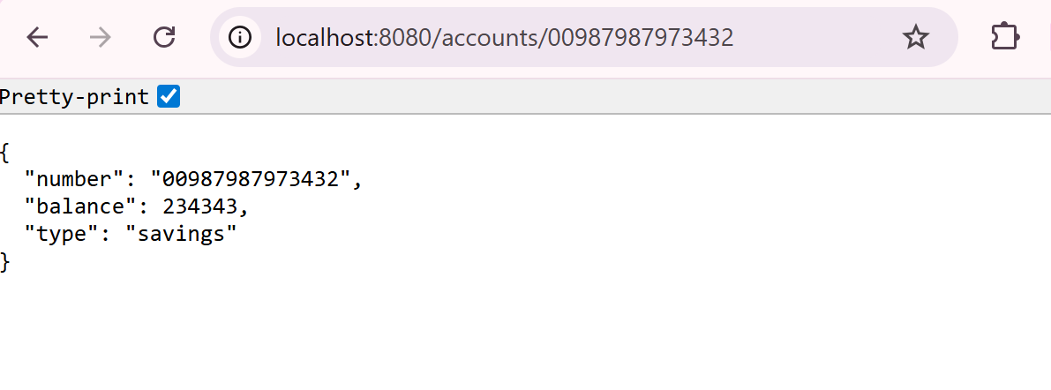

**LOAN MICROSERVICES**

**LoanApplication.java**

package com.example.loan;

import org.springframework.boot.SpringApplication;

import org.springframework.boot.autoconfigure.SpringBootApplication;

@SpringBootApplication

public class LoanApplication {

public static void main(String[] args) {

SpringApplication.*run*(LoanApplication.class, args);

}

}

**LoanController.java**

package com.example.loan.controller;

import org.springframework.web.bind.annotation.*;

@RestController

@RequestMapping("/loans")

public class LoanController {

@GetMapping("/{number}")

public Loan getLoanByNumber(@PathVariable String number) {

return new Loan("H00987987972342", "car", 400000, 3258, 18);

}

static class Loan {

public String number;

public String type;

public int loan;

public int emi;

public int tenure;

public Loan(String number, String type, int loan, int emi, int tenure) {

this.number = number;

this.type = type;

this.loan = loan;

this.emi = emi;

this.tenure = tenure;

}

}

}

**OUTPUT**

